To: Justin Elszasz, Deputy Director of the Office of Performance & Innovation

CC: Belinda Harris

From: Micah Rufsvold, Data Analyst Applicant

Date: 11 November 2020

Subject: Solid Waste Service Request Trends

**Summary**

The Bureau of Solid Waste (BSW) has answered the call of hundreds of thousands of service requests (SR) in the last three years. Serving this huge volume of essential services is a major undertaking and has overwhelmed the Bureau’s ability to meet its deadlines in many cases. According to SR records, after a spike in overdue services in fall of 2018, the overall percent of overdue services has remained high, hovering around 45%, but Baltimoreans do not experience these delays equitably. This analysis had insufficient data to project the degree to which the burden of late services impacted Baltimoreans whom our government has historically underserved, but using crime data as a rough proxy showed some potentially positive news.

**Background and General Observations**

From 2017 through 2019, the Bureau saw the totals in the table at the bottom of this page for each category of SW request, not including proactive measures. In 2017, 2018, and 2019, the Bureau saw an overall rate of overdue services at 26%, 34%, and 51%, respectively. Obviously, the influx in late 2018 set BSW to face some major challenges in 2019. Further information about that time is required to contextualize this situation.

The overall rate of overdue SR as a percent is a less than helpful metric because residents do not experience lateness as a binary “on time” vs. “overdue.” For the remainder of this memo, average number of days overdue will be the central consideration.

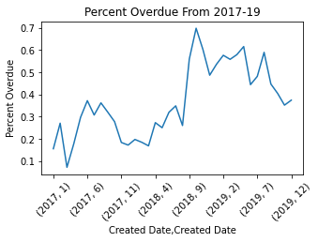**Equity and City Services**

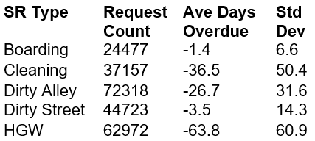There is a significant variation in service speed between neighborhood for most services. The table to the right shows the standard deviation of the average number of days SR go overdue in the neighborhoods. For example, a neighborhood in the 80th percentile for service speed will see their High Grass and Weeds request handled basically on time, but a neighborhood in the 20th percentile can expect to wait three months. SR that are generally submitted by people with institutional power (landlords or the police department (BPD)), like Boarding, do not see this spread.

It is vital that we consider other dimensions of residents lives beyond where they live. Unfortunately, at time of writing, the author does not have access to quality demographic data to map onto the SW request records. City services must be understood in the context of racial and economic justice, so this is a serious limitation of this report.

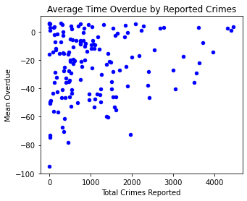However, crime reports from the same time period can serve as an indicator of neighborhoods that need investment.[1] Grouping SR and BPD reports by their geodata shows a very low correlation between crime incidents and service speed in any given area (correlation: ~15%).

To align with Biennial Comprehensive Crime Reduction Plan (2019), BPW and BSW must publish their plan to engage in anti-violence efforts. One strategy that could be implemented is shifting resources to assure that neighborhoods that have suffered from decades from disinvestment receive priority on their residents’ SR.

**Conclusion**

In the face of a serious mismatch in resources to demand, these data show that the Bureau of Solid Waste has room to grow in the area of equity. Even if services are behind, shifting resources between neighborhoods and between services might close the gap between those that are behind by months and those that are only a few days late.

More comprehensive, detailed analysis could answer the following outstanding questions: What are the neighborhoods that are significant outliers for overdue rates? Is there a correlation between race, socio-economic status, and other identities and quality of service? What are the fiscal, time, and human capital cost differences between each type of service? How could the Bureau rebalance resources between service types and regions of the City to achieve even better, more equitable outcomes?

1. This metric should be taken with a grain of salt because, since not all communities report crimes at the same rate, a high number of reported crimes might not correlate with neighborhoods that are actually in need of investment.